Northern Hills
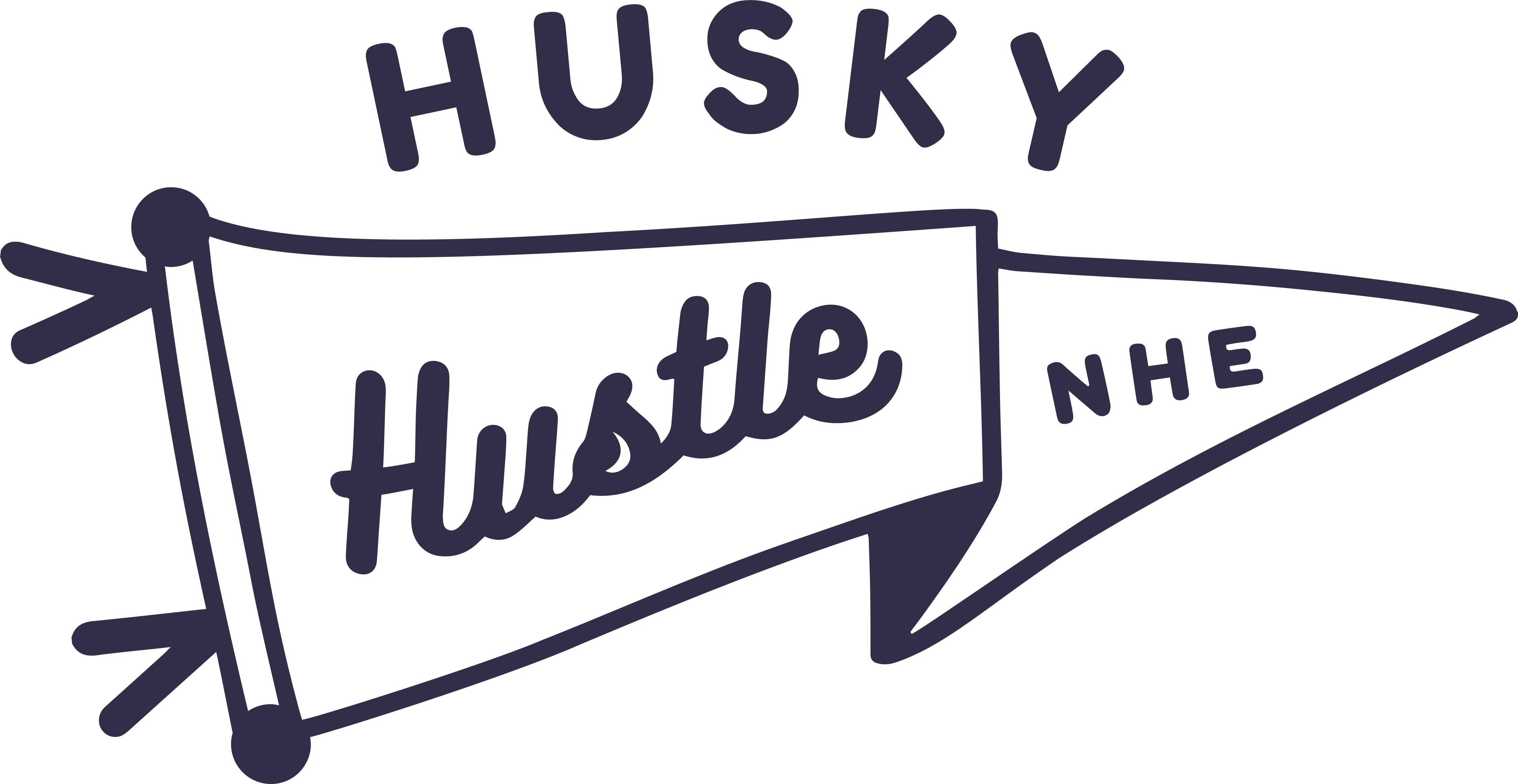
Parent Teacher Organization
901 East Wayne Street
Edmond, OK 73034

Northern Hills Elementary PTO (a 501c3 organization) is excited to host our annual Husky Hustle on Friday, October 2, 2026 – a high-energy fun run that encourages our Husky Pups to stay active while raising critical funds for the youngest and brightest minds in our community.

Husky Hustle is one of the highlights of our school year, bringing together families, teachers, staff, and the community to celebrate health, fitness, and school spirit.

We are seeking your sponsorship to reach our 2026 fundraising goal of $30,000+.

Your sponsorship will directly support:
- Classroom resources and technology upgrades
- Enhanced art and music programming
- Free and low-cost family engagement events
- Our overall PTO operating budget

As a sponsor you will be recognized through our promotional materials, event signage, and direct outreach to families – giving your business meaningful exposure to over 500 students and their families at Northern Hills Elementary. This is an incredible opportunity to show your support for education and community health.

Donor Levels & Recognition:

Bronze Level: $100 | Silver Level: $250 | Gold Level: $500 | Platinum Level:  $1000 or More
- Social media and other public relations recognition | - Sponsor name listed on shirt given to over 500 students and staff on race day  - Social media and other public relations recognition | - Sponsor logo displayed on shirt given to over 500 students and staff on race day  - Sponsor-provided banner displayed at the event for friends, family, students and faculty to see  - Social media and other public relations recognition | - Sponsor logo gets top billing on shirt given to over 500 students and staff on race day  - Sponsor-provided banner displayed at the event for friends, family, students and faculty to see  - Social media and other public relations recognition

We are excited to partner with you to make the 2026 Husky Hustle our most successful event yet. Your support will help us meet our goal for the students of Northern Hills Elementary.

Contact Lesley Wempe TODAY to discuss your sponsorship level: (713-855-5544 or HuskyHustle@NorthernHillsPTO.com)

